SOUTHERN UNIVERSITY COLLEGE

ACADEMIC YEAR 2020

TEST 2

**BTIS3063 DIGITAL MEDIA MARKETING**

DATE: 15 July 2020 TIME:

BACHELOR OF SOFTWARE ENGINEERING (HONS)

YEAR ONE / TWO / THREE

**Instruction to Candidates:**

Answer **ALL** questions. All questions carry equal marks.

Answer ALL questions in Word format.

Save it as Portable Document Format (PDF)

Name it as Test2\_\_BTIS3063\_2020B\_<studentID>. For instance: *Test2\_BTIS3063\_2020B\_B111111C*

Submit through designated Microsoft Teams’ assignment section.

Submit back-up copy through destinated OneDrive: <https://southernuniversitycollege-my.sharepoint.com/:f:/g/personal/lc3547_sc_edu_my/EjYPVDujqLxNiJ-VTrh5IO0BfvUflvpb8r9PAzVq2JtKFg>

1. Explain the online buying process based on Lazada Malaysia eCommerce platform.

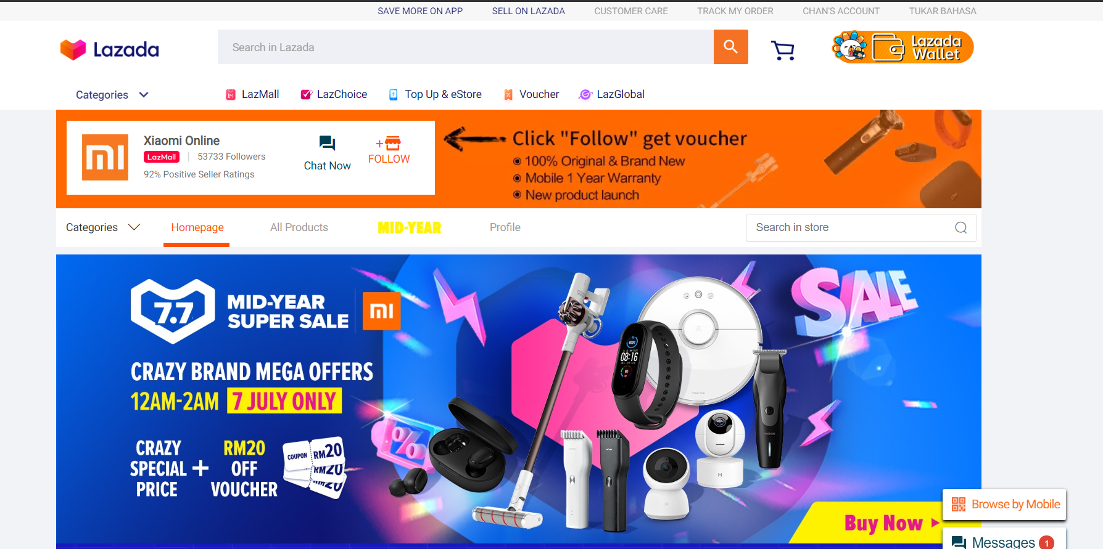

Image credit: <https://www.lazada.com.my/>

|  |  |
| --- | --- |
| Criteria | Explanation |
| Awareness / Findability | Figure :https://cedcommerce.com/blog/top-ecommerce-sites-malaysia   * Lazada is one of the top eCommerce websites in Malaysia.     Figure :Lazada.com   * Lazada provides great search function to allow the consumer to search the product by related keywords.      * Lazada has on-site banner ads that show the current hot items.      * Lazada has use opt-in-email to notice the promotion to new register account. |
| Evaluation | Figure : https://www.lazada.com.my/products/ps4-pro-1tb-playstation-4-pro-1tb-bundle-sony-malaysia-warranty-i105288617-s106636730.html?spm=a2o4k.searchlist.list.1.14f0774b1776vG&search=1   * Each Product has the Main description, other detail. * Each Product has the Product pricing and image.     Figure 4: https://www.lazada.com.my/products/ps4-pro-1tb-playstation-4-pro-1tb-bundle-sony-malaysia-warranty-i105288617-s106636730.html?spm=a2o4k.searchlist.list.1.14f0774b1776vG&search=1   * The consumer can give the comment and rating the product. * Other consumer can view the rating and comment to analysis and evaluate the product. |
| Decision / Purchase | Figure 5: https://www.lazada.com.my/privacy-policy/   * **Giving Security of Your Personal Data.** * Restricting access to personal data to individuals who require access. * Maintaining technology products to prevent unauthorised computer access. * Using 128-bit SSL (secure sockets layer) encryption technology when processing your financial details. * Limit below 18 ages of user to buy products.     Figure 6: https://www.lazada.com.my/products/ps4-pro-1tb-playstation-4-pro-1tb-bundle-sony-malaysia-warranty-i105288617-s106636730.html?spm=a2o4k.searchlist.list.1.14f0774b1776vG&search=1   * Lazada is give some product discount in specific time.      * The delivery options can be selected based on different shipping address. |
| Support | * Lazada has record down the order history.      * In the help center of Lazada, there are a lot Frequently Asked Questions (FAQs) that available for customers to solve their questions. * For Buyer, the questions are “How many voucher am I entitled to? Or What is the validity of voucher?”     Figure 7: https://sellercenter.lazada.sg/seller/helpcenter/how-do-i-know-when-there-is-a-new-order.html   * After consumer ordered, seller will receive an email notification when a new order is received.   How do I know if my Order has been confirmed?  Figure 8: https://www.lazada.com.my/helpcenter/How-do-I-know-if-my-Order-has-been-confirmed-8002.html   * After consumer ordered, buyer will receive an email notification for notice order status. |
| Rewards | Figure 9: https://www.owler.com/company/lazada   * Lazada put the trending news for advertisement. * Lazada has competitions with its competitors in trending news.     Figure 10: <https://www.owler.com/company/lazada>   * Lazada has the most employee between the competitors. * Lazada has the most funding at 3.7billions between the competitors.      * Lazada also send some gift to the customer that to encourage them to use the Lazada wallet for the purchasing in Lazada. |

TOTAL: 25 marks

1. Refer to the case study “[How SEA marketers can use video to inspire shoppers to take action.](https://www.thinkwithgoogle.com/intl/en-apac/ad-channel/video/how-sea-marketers-can-use-video-inspire-shoppers-take-action/)”, describe the customer behaviors with customer information processing model. You may use any relevant resources to further clarification.

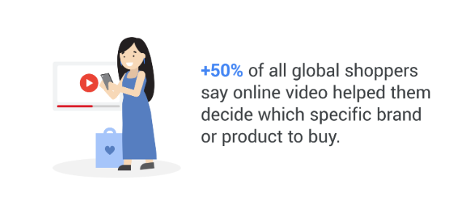

Image credit: <https://www.thinkwithgoogle.com/intl/en-apac/ad-channel/video/how-sea-marketers-can-use-video-inspire-shoppers-take-action/>

|  |  |
| --- | --- |
| Model | Explanation |
| Exposure | * While researching the different ways consumers in SEA use online video, we’ve seen that people increasingly rely on video at every step of the consumer journey. * Nearly 85% of users in SEA watch online videos every day to do everything from brushing up on personal skills to discovering new brands.     (thinkwithgoogle, 2020)   * 90% of respondents to a global survey said they discover new products on YouTube. * While more than half of all global shoppers say online video has actually helped them decide which specific brand or product to buy. |
| Attention | * From early awareness and consideration to the final purchase, online video sits front and center. * Increasing audible or visual stimuli in video or ads to grab the attention of customers more easily * Anticipating consumers’ needs and tapping into their intent at each stage.      * 80% of shoppers switch between search and online video when researching which product to buy. * While video can drive great results on its own, brands looking to turbocharge bottom-line growth should run search and video in tandem. |
| Comprehension and perception | * The video should focus on describing the characteristics of the product, rather than focusing on explanation. * Use google lens to find similar product and see what makes them special and to do something different enough that will make your product stand out from your competitors * Put some special things on our product labels, such as a variety of color combinations, the point is not to be too strange, this can enable customers to have a better understanding of our products. * The consumer is influenced based on three categories which as Characteristics of the Message, Characteristics of the Message Receiver and Characteristics of the Environment. * While being influenced by these three things, the consumer is also processing both cognitive and affective elements. Meaning the message is weighing on their thoughts and feelings to interpret and send that message to your brain and figure out how to respond. |
| Yielding and acceptance | * Whether your goal is generating leads, driving foot traffic, or boosting online purchases, this guide offers practical tips and success stories to help you develop compelling campaigns that make an impact.      * In the playbook, you’ll see how education technology brand [Mindvalley](https://www.mindvalley.com/" \t "_blank) increased its subscriptions by 500% in just one year,      * The sporting goods retailer [Decathlon](https://www.decathlon.com/) drove 175% more online conversions and 28% more in-store visits at less than half the cost. |
| Retention | * Giving regular discounts will ensure that they continue to stay, and even provide customers with some special fees, such as an additional 5% discount or cashback will allow them to continue to stay. * Give the first consumer discount, and prompt consumers to buy more will have more discounts, which makes consumers feel that there will be many discounts and discounts in the future. * Send existing customers emails about new products, promotions or vouchers, or make consumers members, which helps retain customers. * The most important thing is the quality and value of the product itself. Good products are not afraid of nobody buying. Good quality can better retain consumers. |

TOTAL: 25 marks

1. Refer to case study below:

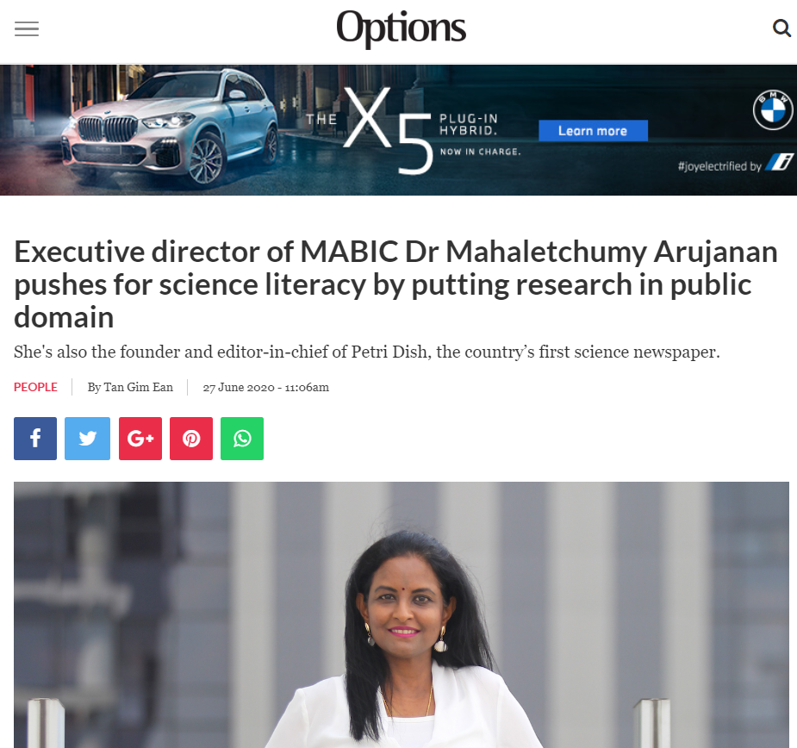

Image Credit: Options The Edge

Source adopted from <https://www.optionstheedge.com/topic/people/executive-director-mabic-dr-mahaletchumy-arujanan-pushes-science-literacy-putting>

Assume that you are hired as digital media consultancy for Dr. Mahaletchumy Arujanan. Dr. Mahaletchumy just launched Malaysia’s first science newspaper, Petri Dish.

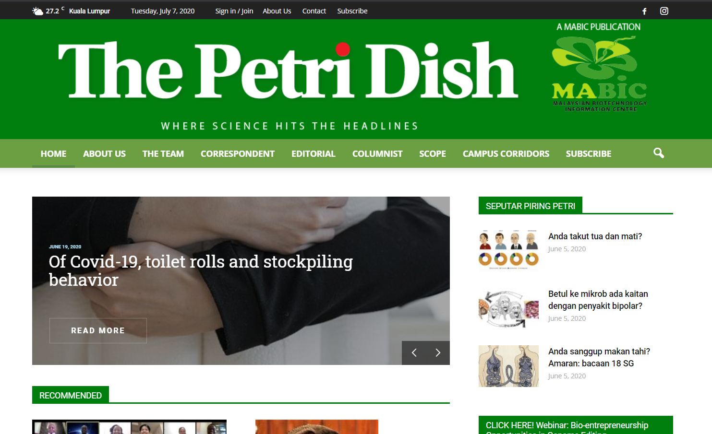

Image Credit: <https://thepetridish.my/>

1. Propose FOUR (4) online revenue models for the Petri Dish. (4 marks)

* Revenue from the subscription access to content.
* Revenue from Pay Per View access to documents.
* Freemium.
* Subscriber data access for e-mail marketing.

1. Distinguish between the four online revenue model stated in 3 (a). (20 marks)

|  |  |  |
| --- | --- | --- |
| Models | Advantages | Disadvantage |
| Revenue from the subscription access to content | * Steady revenue stream. * A built-in base for up-selling and customer inertia, which reduces cancellations. * Easier for customer to budget because they are regular reminded of the products. | * Use of a per-shipment billing process offers cancellation opportunities. * the business has to deal with a lag time to reduce production after a cancellation. * Company need to consistently providing value to customer. |
| Revenue from Pay Per View access to documents | * It can generate large amounts of revenue. If you’re able to attract a decent audience size, income can add up quickly. * It may have a very small target audience, but if they’re willing to pay a premium price for quality video than it still coming out ahead. | * they’re not making a long-term commitment to your brand. They may simply watch once and then leave. That means it’s up to you to turn them into long term customers. * Company is difficult to predict revenue because customer buy the product on their schedule. |
| Freemium | * Company can create a captive audience with the right product. * People love free things but are willing to pay when they get hooked on your product. * Increased brand awareness because they believe the higher the price of a product better will be its quality. | * It may hard to define the boundary between free and paid access. * Require more costs to create premium version. * Difficult to convert the users to paid customer. |
| Subscriber data access for e-mail marketing | * Cost-effective because sending out the e-mail newsletter is very cost effective. * Save time because the create an e-mail newsletter is a lot shorter than creating campaigns for traditional media. * Flexible design of message because it can send plain text, graphics or attach files. | * Design problems of message may rise up due to different devices and email providers. * Being branded as a spammer can occur if you send emails too often with content that doesn't add value to your audience. |

1. Based on the comparison result on 3 (b), recommend the most suitable online revenue model to Dr. Mahaletchumy. (1 marks)
   * Revenue from the subscription access to content

TOTAL: 25 marks

1. The 6Cs of customer motivation are content, customization, community, convenience, choice and cost reduction. Analyses the Malaysians’ buying motivation changes during Movement Control Order (MCO) by using FIVE (5) ‘C’ from the 6Cs of customer motivation.

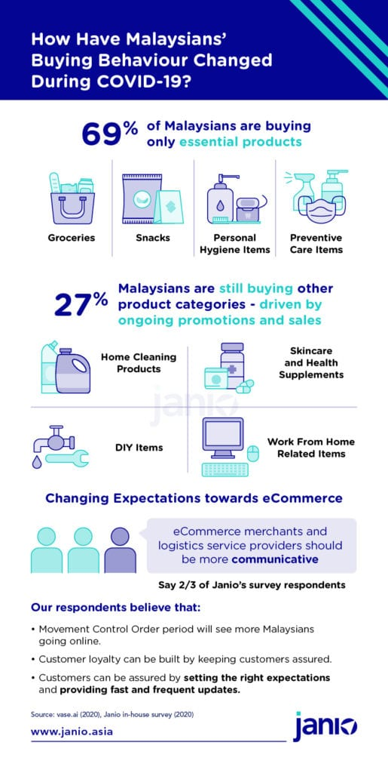

Image credit: <https://janio.asia/wp-content/uploads/2020/04/COVID-19s-Impact-on-Malaysias-eCommerce-Market-Infographic-2--515x1024.jpg>

|  |  |
| --- | --- |
| Criteria | Explanation |
| Content | * During the Movement Control Order (MCO), businesses and stores deemed non-essential were ordered to suspend operations. * Various rules for social distancing have also been implemented, such as only allowing one person per household to leave the house for matters such as grocery shopping and closing roads in various parts of the country to limit movement. (Janio, 2020) * MCO has led to a lot of online shopping. * 60% of respondents mentioned that they have been making more purchases online compared to pre-COVID levels. * Vase.ai’s study showed that popular online grocery stores included Tesco Online and My-Din Online. |
| Customization | * + People need to maintain a distance of 1 meter during the MCO outdoors.   + People must wear masks when going out.   + Schools and university begins to have classes online during MCO.   + People also start to use foodpanda and grabfood frequently to order and delivery products.   + The contactless between people and people are achieved as low as possible also during the online purchasing. |
| Community | (Janio, 2020)   * Two-thirds of our respondents expect eCommerce players to be more communicative.     (fb, 2020)   * + There are some facebook group which are created by the community to allow the people for sharing their food delivery information through the Facebook.   + There are also people who start to perform some business to maintain income. |
| Convenience | * Online shopping allowing Malaysian to shop at home without contact others. * Since everyone are forced to remain at home during the MCO period, most of the people are encouraged to buy their needs through e-commerce. * The rate of spreading the virus (COVID-19) because the contactless between people and people are achieved as low as possible also during the online purchasing. * More and more online food delivery services are used to deliver our favorite foods to the door without going out. |
| Choice | * 69% of respondents say they are only spending on essential food and household items. * The peoples mentioned that current ongoing promotions and sales provided them with great savings they didn’t want to miss.      * 27% say they have purchased other items besides food. * These products have more to do with how people are adapting to their new lifestyles. |

TOTAL: 25 marks

\_\_\_\_\_\_\_\_\_\_\_\_\_\_\_\_\_\_0000\_\_\_\_\_\_\_\_\_\_\_\_\_\_\_